

Foundations of Programming
Assignment No. : 03

PROBLEM STATEMENT:
Write a program in C to generate multiplication tables for a given number.

OBJECTIVES:
- To understand the use of looping statements in C.
- To generate multiplication tables using loops.
- To improve program logic and execution flow understanding.

THEORY:
Syntax for for loop example program
Syntax for while loop example program
Syntax for do while loop example program

PLATFORM:
Linux

ALGORITHM:
1)START
2) Declare integer variable n and iterable variable i
3) Display message, enter a number.
4) Read the value of n
5) Start iteration from i=1
6) Repeat step 7-8 while i<=0
7) Print "n x i"= n * i
8) Increment i by 1
9) STOP

FLOWCHART:
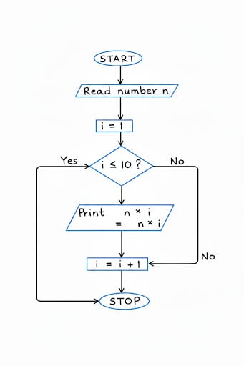

INPUT:
#include <stdio.h>

int main()
{
int num, i;

printf("Enter a number: ");
scanf("%d", &num);

printf("\nMultiplication Table of %d:\n", num);

for (i = 1; i <= 10; i++)
{
printf("%d x %d = %d\n", num, i, num * i);
}

return 0;
}

OUTPUT:
Enter a number: 3
Multiplication Table of 3:
3 x 1 = 3
3 x 2 = 6
3 x 3 = 9
3 x 4 = 12
3 x 5 = 15
3 x 6 = 18
3 x 7 = 21
3 x 8 = 24
3 x 9 = 27
3 x 10 = 30

SAMPLE INPUT:
4
SAMPLE OUTPUT:
Multiplication Table of 4:
4 x 1 = 4
4 x 2 = 8
4 x 3 = 12
4 x 4 = 16
4 x 5 = 20
4 x 6 = 24
4 x 7 = 28
4 x 8 = 32
4 x 9 = 36
4 x 10 = 40

CONCLUSION:
Thus, the menu driven program in C successfully performs basic arithmetic operations using switch–case statements.

FAQs:
- Which loop is best suited for generating multiplication tables?
- What is the role of loop initialization?
- Difference between for loop, while loop and do while loop?
- Can a do–while loop be used to generate multiplication tables? Explain.
- Why is the do–while loop called an exit-controlled loop?

